H.T No
Regulations:
A17

Sreenidhi Institute of Science and Technology
(An Autonomous Institution)
Code No: 6U101 Date: 30-Jan-2019 (FN)

M.Tech I-Year I-Semester End External Examination, Jan/Feb-2019 (Regular/Supplementary)
DIGITAL SYSTEM DESIGN (DSCE)

Time: 3 Hours Max.Marks:75

Note: a) No additional answer sheets will be provided.
b) All sub-parts of a question must be answered at one place only, otherwise it will not be valued.
c) Missing data can be assumed suitably.

Part - A Max.Marks:25

Answer all QUESTIONS.

1. | What is PLA and PAL? Explain. | [3M]
2. | Define path sensitization techniques. | [3M]
3. | Give examples of test pattern generations. | [3M]
4. | Write the principal of distinguishing tree. | [3M]
5. | Discuss the optimization in PLA. | [3M]
6. | Draw the state diagram for Machine M. | [2M]
7. | What are the merits and demerits of SM chart? | [2M]
8. | Mention the merits and demerits of transition count testing. | [2M]
9. | Draw the hazard free circuit. | [2M]
10. | How to Convert a mealy machine to Moore Machine? | [2M]
Part – B Max.Marks:50
ANSWER ANY FIVE QUESTIONS. EACH QUESTION CARRIES 10 MARKS.

11. | a) | Realize F1 and F2 using PLA. Give the PLA table and internal connection diagram for the PLA  F1(a,b,c,d)=∑m(1, 2, 4, 5, 6, 8, 10, 12, 14)  F2(a,b,c,d)=∑m(2, 4, 6, 10, 11, 12, 14, 15) | [5M]
 | b) | Compare and contrast PLA and PAL with advantages and disadvantages? | [5M]
12. | a) | Determine the minimal sum-of-product form for the expression and give the tabular  method for f(w,x,y,z)= ∑m (0 ,2, 4, 9, 11, 13, 15, 15) +∑ m(1, 5, 7, 10) | [5M]
 | b) | Explain the different Faults presented in combinational circuits with examples. | [5M]
13. | a) | Explain with example, how the output response is compacted using exhaustive testing? | [5M]
 | b) | Compare and contrast various test pattern generations. | [5M]
14. | a) | Describe the design of fault detection experiments for the sequential circuits. | [5M]
 | b) | Design the steps to generate the complete test sequence for Sequential machine M of table.  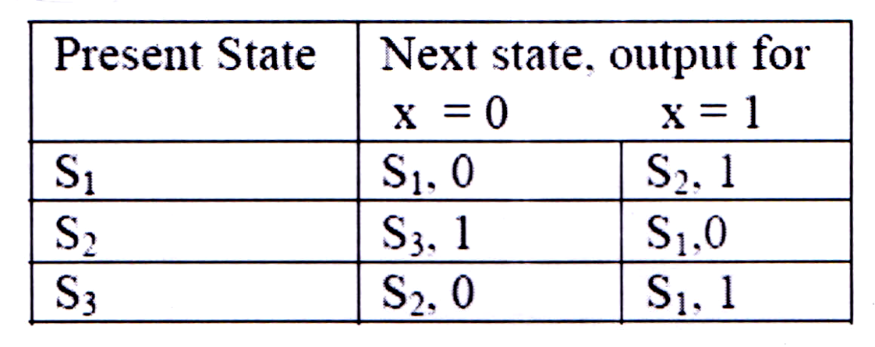 | [5M]
15. | a) | Draw the block diagram of PLA and give the Design aspects in a PLA. | [5M]
 | b) | Explain the procedure steps of PLA folding algorithm and illustration of algorithm  With suitable example. | [5M]
16. | a) | Find a circuit that has no static hazards and implement the Boolean function F(A,B,C,D)=∑(0, 2, 6, 7, 8, 10, 12). | [5M]
 | b) | What are the capabilities and limitations of FSM? Explain. | [5M]
17. | a) | Draw the data path circuit and ASM chart to implement a traditional type serial adder accumulator. | [5M]
 | b) | Define Kohavi algorithm? Explain this algorithm with one example. | [5M]
-- 00 -- 00 –

